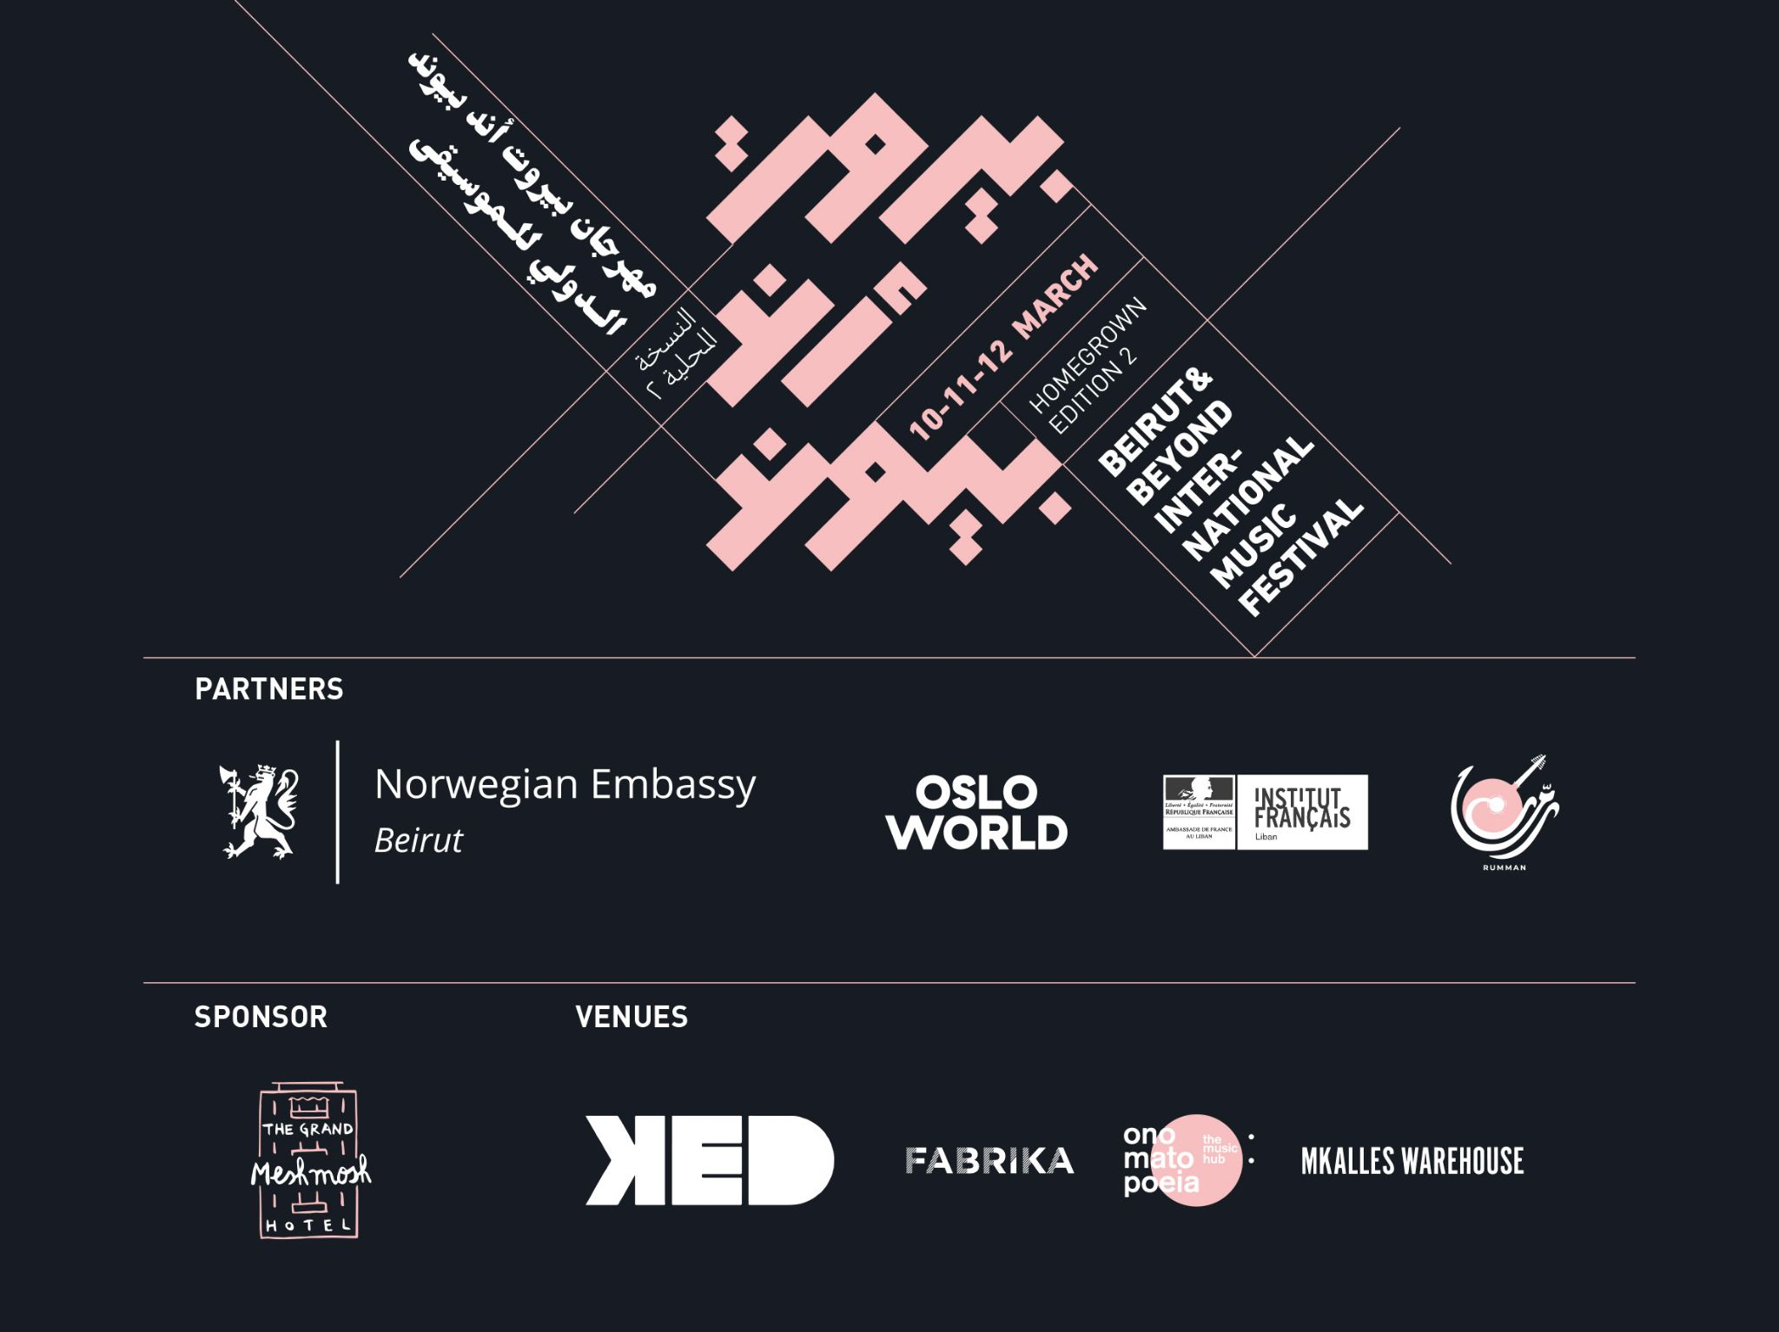

Beirut and Beyond is back with another homegrown edition of its international music festival this coming March on the 10th, 11th and 12th.

//ABOUT BEIRUT AND BEYOND
Back in 2013, Beirut and Beyond came to fruition as a yearly showcase festival, one during which the regional musical talent got the chance to promote their art. There is no doubt that Beirut and Beyond underwent a metamorphosis over the years, no more so than over the past two years, uplifting and changing its identity and adapting its missions as a response to the current events Lebanon has been suffering from. B&B became an entity that fosters the independent music scene’s infrastructure, catering to its ever-changing needs, such as development programs and capacity-building, to name a few.

//ABOUT BEIRUT AND BEYOND INTERNATIONAL MUSIC FESTIVAL
BBIMF is a yearly showcase festival that aims to promote and support both rising and established artists from the MENA region and beyond. We always thrive to shed light on new talent, mix genres, and respect gender equality.
The urgent needs of the bustling state of artistic production in the region, which is hardly matched by an infrastructure that drives it to more sustainable grounds, gave birth to our yearly professional program. Happening in parallel to the artistic program, it aims to equip local artists with the right tools to carve their musical future. This is done by making the resources and experience of international professionals available to local artists through a program of panels, workshops, Meet the Artists sessions and more.

//BBIMF HOMEGROWN EDITION 2
The first homegrown edition took place in 2020 as a response to the unprecedented events that rocked Lebanon that year. The goal was to support the local independent scene by shifting the focus towards the local players and calling on international professionals to share their experience with them and provide them with support. Given the current circumstances, we have decided to organize yet another homegrown edition this year, on the 10th, 11th and 12th of March.

The 3-day showcase festival will comprise two programs: an artistic program, featuring mainly local acts; and a professional program, welcoming over 15 international professionals from different parts of the music industry, shedding light on the local music scene in its current state.

//ARTISTIC PROGRAM
In KED Beirut - doors open at 8:00pm
Tickets on ihjoz.com | 75,000 LBP per night | 200,000 LBP festival pass.

Thursday 10 March
Tarek Yamani Trio (LB)
Rust (LB/SY)
NP (LB)

Friday 11 March
Knut Reiersrud (NO)
Postcards (LB)
Wael Alkak (SY/FR)

Saturday 12 March
Mayssa Jallad (LB)
Yara Asmar (LB)
Bedouin Burger (LB/SY)

//PROFESSIONAL PROGRAM

Wednesday 09 March

//Masterclass with Norwegian musician, Knut Reiersrud

Knut Reiersrud will be giving a masterclass in music compositions, while sharing his musical inspirations and journey as a guitarist and composer.
known for his collaborations with musicians from different music genres. He has a large number of record releases under his own name, and contributions on around three hundred recordings. Reiersrud has been a performing musician since the early 1970s and has composed a number of works. He has won three Spellemann Prizes ( Norwegian Grammy Awards), and has been nominated eleven times.

Friday 11 March
11:00 - 13:00 - FABRIKA, Ashrafieh, Lebanon.
// MEET & GREET
a casual networking session over brunch to introduce the international delegates attending BBIMF to the local music scene, professionals, artists and actors.

13:00 - 15:00 - FABRIKA, Ashrafieh, Lebanon
// MEET THE ARTIST SESSION
A speed meeting session to introduce the international professional to 10 selected local artists who will be pitching their music and new projects.

5:00-7:00 PM - Mkalles Warehouse (Frequent Defect location)
// DISCUSSION - ​​BEIRUT: TODAY’S MUSIC SCENE
A dive into the local scene as it is today, through conversations with key players that have been active, in one way or another, in the past 2 years.
The discussion covers what’s being done around Beirut, the challenges faced, and how to move forward… What's next for Beirut’s music scene?
// SHOWCASE
Presented by the founders of the Beirut Synthesizer Center.

Saturday 12 March
// City escape - Tripoli
In collaboration with Rumman, Institut Francais and FIMU festival in Belfort, France, we are inviting all international professionals for a day in Tripoli, where we discover the city, its cultural and heritage places, and enjoy a showcase of local talents, in the presence of the president of the Tripoli Municipality.

Some of the represented organizations at BBIMF HG2:
FIMU • Berklee, Abu Dhabi • Sinsal Audio • Maisumdiscos • Small World Music • Global Toronto • Asterios • Molocco • Silex • Les Escales • Nancy Jazz Pulsations • The Fridge • Theatre de La Ville

Thursday 10 March

Tarek Yamani Trio
Beirut native Tarek Yamani returns to the BBIMF stage once again. Yamani is a pianist and composer who, at 19, taught himself jazz. His explorations into Black American and Arabic music can be heard in his second album "Lisan Al Tarab: Jazz Conceptions in Classical Arabic", and in his 3rd release “Peninsular”. An award-winning artist, Yamani was recently commissioned by the UMS Digital Artist Residency to write “Berytus”, his first string quartet for multi-Grammy nominated Spektral Quartet. He has been part of three editions of the International Jazz Day all-star concerts and performed in venues such as the Smithsonian (DC), Barcelona Cathedral at La Merce, Atrium at Lincoln Center (NYC), and Boulez Saal (Berlin), to name just a few. Yamani is also an educator, author of two self-published music books on rhythm, and a prominent film score composer.
He’ll be revealing on Thursday 10, the opening night of #BBIMFHG2, new work of his upcoming album alongside, for the first time in Beirut, Elie Afif on Bass and Khaled Yassine on drums.

Rust
A Beirut-based musical project, Rust blends traditional Arabic vocals with unique synthesized sounds, creating an altered, transcendental experience. Petra Hawi on vocals and Hany Manja on synths, both from different musical backgrounds, formed Rust with a common interest and vision: to revive the Arabic musical tradition in a new way that resonates with this generation’s tastes. Hawi is a Lebanese musician and vocalist based in Beirut, with a background in Oud and Arabic singing, and has been performing since 2012 with several bands in Lebanon. Manja is a Damascus-born musician and electronic music producer who moved to Beirut to reconnect with his roots, after spending fifteen years in Prague. He’s released several singles and an EP, and has composed music for short movies, museum installations, and commercial projects.
They’ll be performing their unique and mesmerizing music live with drum machines and synthesizers along with live vocals, in addition to cover songs chosen from the repertoire of classical Arabic compositions, reviving Arabic music by infusing it with contemporary sounds.

NP
Formed in 2019, NP is electronic, experimental duo Jad Atoui and Anthony Sahyoun reflecting on the current political transformation and its uncertainties as a method to explore musical futures. Atoui and Sahyoun have made a name for themselves locally through their performance of both extended experimental music and banger live dance music. They’ve collaborated with Joe Saade on video works, having presented a one-hour long film on introspection through extrospection for Lumens Stockholm. They also host various workshops on the use of programming for music production. They’ve played various shows around Beirut and the UAE, as well as Cineconcerts and extended band formats with Kinematik, Fadi Tabbal and Bana Haffar.
The duo is sure to electrify the night once they take the stage, with a performance that utilizes acoustic objects, modular systems, and programming.

Friday 11 March

Knut Reiersrud
Norwegian guitarist and composer Knut Reiersrud is known for a number of collaborations in various music genres. He has a large number of record releases under his own name, and contributions on around three hundred recordings. A profiled concert artist, Reiersrud has been a performing musician since the early 1970s.He’s won three Spellemann Prizes (Norwegian Grammy Awards), and has been nominated eleven times.
Reiersrud has toured in several small towns in Bekaa in the 1980’s, but now will be taking the stage with vocalist Marit Halvorsen on March 11th, giving the crowd one of his highly memorable performances.

Postcards
Postcards is a dream pop trio formed in 2012 in Beirut, Lebanon. Their music is defined by hushed vocals floating over expansive soundscapes that shift between harsh noise and dreamy atmospheres. They have three EPs and albums under their belt, and have been touring Europe and the Middle East regularly since 2014. Their third full-length album “After the Fire, Before the End” came out on October 15, 2021. Written between January 2020 and January 2021, it is a record of the devastating year that the country witnessed, through the eyes of the band. They recently completed a 12-day residency in Byblos as part of the Beirut and Beyond residency program.
The trifecta of performers are going to be nothing short of impeccable when they play their last release but also new, unreleased material from their residency at the #BBIMFHG2

Wael Alkak
A Franco-Syrian based in Paris since 2012, Wael Alkak is a composer and electronic music producer who trained in classical knowledge at the Conservatory of Damascus. He joined the Syrian National Orchestra and various collectives of musicians, from jazz and funk to Arab classical music. He plays the sax, piano, and bouzouk, and works as a film composer. “Neshama” is his first album, which was inspired by the revolutionary anthems from the peaceful demonstrations in Syria in 2011.

Alkak tours in France and Europe with his solo electro music project “Wael Alkak Live” and his band, Neshama. A hybrid and experimental musical creation, his live performances merge synthesizers and machines with traditional Chaâbi rhythms and popular Levant melodies. They reflect a work of memory on the richness of Syrian culture, while making independent art inspired by European electronic cultures. In 2018, the founder of the Neshama popular arts association won the WOMEX18 (club summit official selection).

Alkak takes center stage at the #BBIMFHG2 to give audiences a blend of his distinct music.

Saturday 12 March

Mayssa Jallad
As a Beirut-based bilingual singer-songwriter, Jallad’s work deals with the highly personal as well as the political, heard in her upcoming first solo album “Marjaa 1: The Battle of the Hotels”. The album explores the histories of urban battles that occurred before she was born, during the Lebanese Civil War, through a collaborative musical and architectural lens. She received the Lukman Slim "Sounds of the City" Prize in February 2022, for a song in memory of the journalist and mentor, after his assassination. She has performed and written music with the indie band Safar, releasing debut album "In Transit" and a follow-up EP "Studies of an Unknown Lover" with Lebanese producer Fadi Tabbal at Tunefork studios. Jallad has also performed with Lebanese producer Zeid Hamdan as part of the band "Zeid and the Wings".
Expect a riveting show by Jallad, joined by the talented Khaled Allaf, on the 12th, with vivid music to fill both heart and soul.

Yara Asmar
A musician and puppet-maker, Yara is a natural-born creator and artist. Along with the accordion, metallophone, and synthesizer, she incorporates different toys and materials into her musical practice, proving that melodies can form from the most unusual of places and things.

Bedouin Burger
Artists Lynn Adib and Zeid Hamdan began Bedouin Burger as a way to blend their ideas and produce delicious tracks. With Arabic, jazz, and bedouin music flowing through her veins, Adib writes and sings to touch and elevate the sensitive soul, while Hamdan has his own unique flavor when it comes to producing and composing Arabic electro pop music. Known as one of the godfathers of the Arab indie scene, his contribution to its music is essential.
The duo will be giving #BBIMFHG2 a taste of those tantalizing beats, and it can’t come soon enough!

