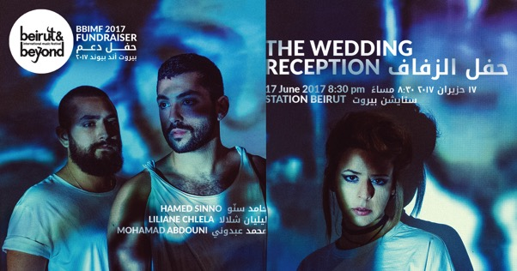
Press release 24.05.17
BBIMF 2017 fundraiser brings together Mohamad Abdouni, Liliane Chlela and Hamed Sinno
After the resounding success of its fourth edition last December, Beirut & Beyond International Music Festival is back this year with a special fundraising concert taking place on June 17 in STATION Beirut and featuring three of Lebanon’s most talented artists.
In line with BBIMF’s continuous support of local and international collaboration, BBIMFis producing “The Wedding Reception,” a special collaborative audio-visual performance by artist, photographer and filmmaker Mohamed Abdouni, multidisciplinary producer and musician Liliane Chlela and singer-songwriter and frontman of Mashrou’ Leila Hamed Sinno.
“The Wedding Reception” explores the tensions running beneath the surface of a wedding held in Summerland, Beirut, in 1988, during the Lebanese Civil War. Using film footage, the three artists have worked together to create a masterpiece of visuals and music, with Liliane as producer, Hamed on vocals and Mohamad in charge of visuals. Sonically and visually unique, their performance tells stories of fleeting moments and unmasked emotions, exploring the reactions and interactions of characters at an event riddled with discontent.
As festival director Amani Semaan puts it, “attending “The Wedding Reception” is a perfect way for music lovers to support Beirut &Beyond’s 2017 programme, which as ever promises quality, originality and diversity”.
Support Tickets are on sale at Librairie Antoine and Antoine Onlineat 75,000LBP and 150,000LBP
#BBIMF2017 #SupportBBIMF

More information  Press release in doc format and high-resolution photos available for download here: http://www.beirutandbeyond.net/press/ | Contact  India Stoughton  press@beirutandbeyond.net  00961 70214486

About the Artists
Hamed Sinno is a Beirut-based singer-songwriter and the frontman of well-known indie-pop band Mashrou’ Leila, which he founded with friends in 2008 while studying graphic design at the American University of Beirut. His work delves into themes including the intersections of gender, race and language and he writes and lectures on the convergence of music and social justice.
Liliane Chlela is best known for her improvised sets on electronics, synth, cello and guitar – among other instruments. Based in Beirut, Liliane is a multidisciplinary musician and producer and her numerous collective projects cover jazz, post rock, drone, drum ‘n’ bass and ambient sound. Interested in exploring the connections between improvised music, image and movement, she also produces music for short films, art installations and contemporary dance performances.
Mohamad Abdouni is a multidisciplinary visual artist, photographer, filmmaker and curator based in Beirut. In 2012, he founded F/I/M2/P magazine, a print publication focusing on arts and culture in the Middle East, and is currently preparing to launch a new publishing platform, “Cold Cuts.” Music plays an integral role in his projects, including several documentaries on photo series, whichtend to focus on the untold stories of Beirut and the rising queer culture of the city.

About Beirut & Beyond
Dedicated to promoting the Arab region’s independent music with an emphasis on strong artistic merit, Beirut & Beyond was founded in 2013, in partnership with Oslo World Music Festival, andquickly succeeded in positioning itself as a key player on the map of regional festivals and showcases. As a platform for meetings, showcases and exchange, Beirut & Beyond encourages networking and collaboration. It also aims to offer solutions to the urgent needs of the young Arab independent music scene, such as the necessity for outlets to showcase its burgeoning artistic productions.

