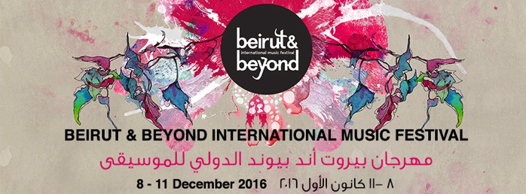
PRESS RELEASE 08.12.16

Beirut & Beyond International Music Festival 2016 kicks off tonight promising great music

“We promise you a distinguished 2016 edition, colorful and eclectic!” – Amani Semaan, Festival director
BBIMF 2016 kicks off tonight, with an intensive program of live music concerts, workshops, discussions and DJ sets stretching through Sunday 11 December.
On Thursday 8, Kamilya Jubran opens Beirut & Beyond 2016 with Wasl Trio, her collaboration with Sarah Murcia and Werner Hasler. This will be followed by the eagerly awaited performance of Algerian electric ‘oud player Mehdi Haddab and Speed Caravan.
On Friday 9 December, Lebanese folk singer-songwriter Youmna Saba will open the festivities, performing songs from her new album. Next up will be Tunisian electronic musician Wael Jegham aka Ghoula, performing his most recent release “Hlib el Ghoula”. Ghoula will be followed by Moroccan electro-oriental superstars N3rdistan.
On Saturday 10 December, Station will host the Lebanese-Syrian electro/hip-hop duo Chyno & Al Rajul al Hadidi, followed by Alo Wala, the high-octane pairing of Punjabi-Indian rapper Shivani Ahlowalia and Danish production unit Copia Doble Systema. Armenian-American producer Bei Ru will round off the evening in style, playing excerpts from his latest release “L.A. Zooo”.
On Sunday 11 December, renowned Sudanese diva Alsarah and her band The Nubatones will be performing excerpts from their recent album “Manara” at Station; the festival will end with a blast, with Rayess Bek and Randa Mirza performing their impressive audiovisual performance “Love & Revenge”.
BBIMF 2016 also proposes two public discussions, taking place in Dar el Nimer for Arts & Culture, addressing music infrastructure in the Arab region on Friday 9th, and music and identity on Saturday 10th.

Unique ticket price: 30.000LBP | Tickets on sale in all branches of Librairie Antoine & Antoine Online #BBIMF2016

More information  Press release in doc format and high-resolution photos available here: http://www.beirutandbeyond.net/press/ | Contact  Karim Massoud  press@beirutandbeyond.net  +961 76760212

