PRESS RELEASE 14.11.16

Beirut & Beyond International Music Festival 2016 - an edition beyond expectations
“In this time of global crisis, musicians, poets and singers are excelling; let us rejoice and celebrate music while we still can” – Wael Koudaih
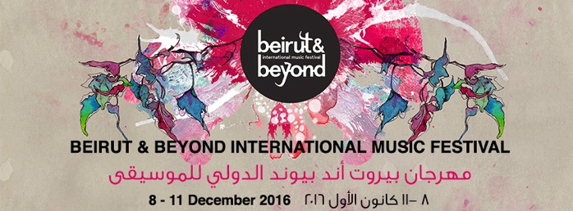
Curated by renowned Lebanese hip-hop pioneer Wael Koudaih aka Rayess Bek, the 2016 edition of Beirut & Beyond, taking place in Beirut from Thursday 8 to Sunday 11 December, is presenting no less than 10 concerts by celebrated and yet to be discovered artists from Lebanon, Palestine, Tunisia, Syria, Morocco, Denmark, Sudan, France, Armenia, Algeria and Switzerland.
Building on the professional gathering that took place in June 2016, Beirut & Beyond is hosting prominent international professionals this December and tailoring a professional program that enables them to meet with local artists and professionals. The program contains two public discussions and a highlight session entitled “Meet the artists” where the festival is selecting a number of Lebanon-based emerging artists for one-to-one speed meetings with international delegates.
Beirut & Beyond 2016 is also proud to be offering an artistic residency to Tunisian emerging band Ghoula, as well as a collaborative residency between Syrian hip-hop crew Latlateh and Lebanese duo Chyno X Al Rajul Al Hadidi prior to their concerts within the festival.
Furthermore, the festival is proposing to local artists an in-depth meeting with renowned artist Kamilya Jubran, as well as the opportunity to develop their knowledge in electronic technology with musicians and producers Mats Lindstrom and Daniel Araya of Elektron Musik Studion (Sweden).
About Beirut & Beyond Dedicated to promoting the Arab region’s independent music with emphasis on strong artistic merit, Beirut & Beyond Founded was founded in 2013, in partnership with Oslo World Music Festival, and quickly succeeded in positioning itself as a key player on the map of regional festivals and showcases. As a platform for meetings, showcases and exchange, Beirut & Beyond encourages networking and collaboration. It furthermore aims to offer solutions to the urgent needs of the young Arab independent music scene, such as the necessity to provide outlets for its bustling artistic productions.

Unique ticket price: 30.000LBP | Tickets on sale in all branches of Librairie Antoine & Antoine Online #BBIMF2016

ARTISTIC PROGRAM
THURSDAY 8 DECEMBER 2016 | METRO AL MADINA

WASL TRIO /KAMILYA JUBRAN Palestine/ France/ Switzerland [8:30PM]
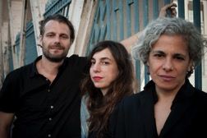
In the Arabic language, Wasl signifies combination, contact or connection. In keeping with the spirit of these definitions, the Wasl project is a meeting point between different historical and musical traditions, brought to the stage by three seasoned musicians inhabiting the works of two poets. Palestinian composer, vocalist and musician Kamilya Jubran has collaborated with French acoustic bass player Sarah Murcia and Swiss trumpeter and electronics producer Werner Hasler since the early 2000’s. The trio creates an intricate and rich musical backdrop for the written works of poets Hassan Najmi (from Rabat, Morocco) and Salman Masalha (from Jerusalem, Palestine), creating in this manner bridges between the Middle East and the Maghreb, and paving the way for a new Arab “chanson”.

SPEED CARAVAN Algeria /France [10:00PM]
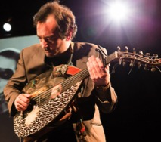
If you've never regarded the oud as a rock'n'roll instrument, then you've clearly never heard the frenetic and joyous playing of Mehdi Haddab! Once part of Parisian-based global electronic trio Ekova and experimental oud duo DuOud, Haddab created Speed Caravan in 2008 with bassist Pascal "Pasco" Teillet, keyboard player Hermione Frank and percussionist/vocalist Mohamed Bouamar. The band is an ethnic fusion collaboration that references in equal measure The Cure and The Chemical Brothers alongside Algerian Rai and other Arabic influences, in a glorious collision of global sounds and styles. Speed Caravan is famed for its electrifying, high-energy stage performances.

FRIDAY 9 DECEMBER 2016 | STATION

YOUMNA SABA Lebanon [8:30PM]
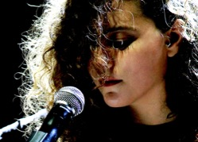
The music of Youmna Saba has anxiety suppressing properties. This is partly due to her singing, but also because of her brilliant arrangements, where an expressive oud is accompanied by shimmering guitars and acoustics of non-musical objects. As a result, her gorgeous third solo album Njoum (2015) sounds hushed and expansive at the same time.
The album caught the attention of British cult hero Mike Cooper - known for his fusion of folk and experimental music - who has since proposed to collaborate with her. As Youmna’s work gains more recognition, we suggest that you too set aside some time to get acquainted with it. It is, after all, the most effective remedy to a hectic day in Beirut.
GHOULA Tunisia [10:00PM]
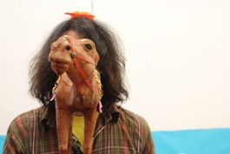
Tunisian multi-instrumentalist Wael Jegham lives between Tunis and Europe and works as a composer in the theater and film industries. “Hlib el Ghoula”, the first release from his fusion project Ghoula, was born as a result of Jegham’s passion for old North African vinyl records. From an early age, he would dig up records from flea markets and play various instruments (guitar, bass, gumbri, keyboards…) over the original music. Gradually he started sampling these found records and layering his own sounds in the mix, creating a new music genre in the process. Since the sampled scales, tones and dialects are often dissimilar; the end result is an eclectic patchwork, representative of North Africa’s diverse cultural heritage. Ghoula’s ultimate goal is to provide a new lease of life to this hidden musical wealth.

N3RDISTAN Morocco [11:00PM]
Often referred to as the future of alternative Moroccan music, N3rdistan is an electro-urban project rooted in Oriental inspiration. Led by the charismatic Walead Ben Selim, this quartet navigates the genres of rock, trip-hop, electro and oriental beat with surprising ease. Relying furthermore on the texts of famous freedom poets such as Mahmoud Darwish, Gibran Khalil Gibran and Nizar Qabbani, N3rdistan tweaks world music samples and sounds, questioning the meaning of digital exile and the multi-plurality of the human condition. They invent a dream space where they call upon centuries of Arabic poetry, traditional music, unusual instrumentation and electronic sounds, inciting the discovery of new musical horizons.

SATURDAY 10 DECEMBER 2016 | STATION

LATLATEH & CHYNO X AL RAJUL AL HADIDI Syria/Lebanon [8:30PM]
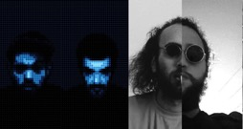
In keeping with its tradition of encouraging novel music collaborations and pairings, BBIMF is proud to present this new collaboration between Syrian hip-hop crew Latlateh and Lebanese duo Chyno x Al Rajul Al Hadidi. Chyno x Al Rajul Al Hadidi is the highly successful pairing of hip-hop with drum machines. Groovy beats, hard-hitting basslines and potent lyrics are some of the trademarks of this duo, founded in 2015 by Syrian/Philippino hip-hop artist Chyno (from hip-hop crew Fareeq el Atrash) and Lebanese beat-maker Nabil Saliba aka Al Rajul Al Hadidi. Watar and Bu Kolthoum formed hip-hop crew Latlateh in Damascus, Syria in 2011. The band’s name comes from the Arabic idea of ‘pep talk’ or ‘street talk’. Latlateh aims to express the yearning of the common people and provide an outlet for ideas and social truths that remain otherwise untold. Their music consists of a finely-honed blend of hip-hop, jazz, soul and classical Arab music. The duo was forced to leave Syria in 2013 due to the ongoing civil war, with band members relocating to Lebanon and France.

ALO WALA Denmark [10:00PM]
Alo Wala is the explosive result of a meeting between Shivani Ahlowalia, a female Punjabi-Indian rapper from Chicago, and Danish production unit Copia Doble Systema, known for experimenting in everything from reinterpretations of traditional Cumbia to Italian Gangsta Rap. Alo Wala is the sound of a new Europe, a new world, and a new way of thinking about one another as belonging to an interconnected global society. Alo Wala spent much of the last couple of years on tour, opening several shows for renowned electro-Kuduro outfit Buraka Som Sistema, and sharing the stage with Run DMC & Mobb Deep, among others. She is currently working on her next release with producers Clap Clap and Branko from Buraka Som Sistema.

BEI RU Armenia [11:00PM]
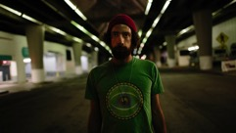
Baruir Panossian aka Bei Ru is an Armenian-American producer and composer known for his blending of Middle Eastern rhythms with electronic sounds and live instrumentation. He was born to Armenian immigrants from Lebanon in Los Angeles, California, and would often cite the old Armenian records his parents listened to in the family home, as a main influence on his music. Bei Ru first came to prominence with Little Armenia L.A (2010), an album created using almost entirely samples of Armenian music. His next album, Saturday Night at The Magic Lamp (2014), expertly navigated the realms of electronica, funk and hip-hop, mixed with Middle Eastern influences and live percussion. In the same year, Bei Ru contributed three songs to stylish Iranian vampire western A Girl Walks Home Alone At Night. He has just released his third album, L.A. Zooo.

SUNDAY 11 DECEMBER 2016 | STATION

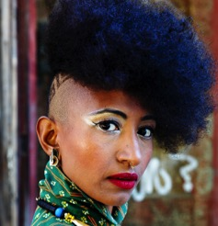
ALSARAH & THE NUBATONES Sudan [8:30PM]
If we listen closely, we find that the strange is often quite familiar. This valuable insight came to Alsarah through her work as an ethnomusicologist, and has been a guiding principle that she brought out in full bloom with Alsarah & The Nubatones. Habibi Taal is a case in point. The languorous opening track from band’s debut, Silt, is a traditional Sudanese wedding song - usually sung by women - that is much maligned by the Sudanese elite. With her rendition of it, Alsarah proves that this music, considered by many to be odd and unworthy, will reward the attentive listener with much beauty and grace. Although Alsarah has been living in Brooklyn since 1994, she still feels like a Sudanese in New York. This may as well explain why Silt - with its gorgeous Oud-solos and arresting vocals - sounds like a musical time capsule dating back to the Nubian sixties rather than 2014 New York. But if 2014 New York is what you’re after, you will find that her club-ready remix of Silt makes the point that the past need not necessarily be incongruous.
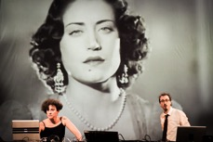
LOVE & REVENGE Lebanon [10:00PM]
“Love and Revenge” is the project of Lebanese hip-hop pioneer and Beirut & Beyond 2016 curator Rayess Bek and visual artist Randa Mirza. It is a musical reflection on identity and dual culture, aiming to give a second life to old Arabic popular songs and movies, by adapting them to the patterns and aesthetics of modern music. Influenced by the writings of Edward Said and Amin Maalouf on identity, “Love and Revenge” consists of the meeting of two hermetically sealed universes, the fractured beats of Western electronic production and the traditional folk music of the Orient. The goal of this creation is to introduce traditional Arabic music to a new audience, whether Arab-speaking or not, as well as to a new generation of young listeners.

PROFESSIONAL PROGRAM | DAR EL NIMER FOR ARTS & CULTURE
FRIDAY 9 DECEMBER 2016

DISCUSSION I [16.00-17.30] – attendance upon registration
An orphaned music | Arab Music and the lack of local infrastructure
Proposed by Wael Koudaih, moderated by artist Serge Yared
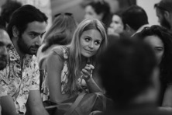
While varied and nuanced music scenes thrive in the Arab world, there still is no viable music industry outside a gigantic pan-Arab pop conglomerate. Musicians have thus far survived by adopting a DIY mentality, and are hampered by limited financial rewards. For that reason they end up having to explore opportunities abroad. In this session we discuss whether it is possible to establish a music industry in today’s Arab world, and reflect on the state of existing organisations. How active and responsive are they? And how far are we from providing musicians with an infrastructure that can support them?

SATURDAY 10 DECEMBER 2016

MEET THE ARTISTS [12.00-14.00] – for registered professionals only

A select group of artists based in Lebanon will have short one-to-one meetings with visiting music professionals to give them an idea of what is happening in the local music scene, and discuss collaborations locally and internationally.

DISCUSSION II [16.00-17.30] – attendance upon registration
You are what you sing | Music & Identity
Proposed by Wael Koudaih, moderated by journalist Maysa Issa
If we agree that music is a means of expression, does this expression necessarily reflect an identity? And if so, is it a priority for Arab musicians to affirm one? To what extent is the identity crisis that is weighing on the Arab world today present in its music? Is it possible to “own” a culture through music? What effect would this have on audiences who recognise themselves in a music deeply rooted in memory and heritage?
WORKSHOPS & RESIDENCIES
RESIDENCIES 2016

GHOULA IN RESIDENCY in partnership with Onomatopoeia the Music Hub
Tunisian multi-instrumentalist Wael Jegham lives between Tunis and Europe and works as a composer in the theater and film industries. “Hlib el Ghoula”, the first release from his fusion project Ghoula, was born as a result of Jegham’s passion for old North African vinyl records. From an early age, he would dig up records from flea markets and play various instruments (guitar, bass, gumbri, keyboards…) over the original music. Gradually he started sampling these found records and layering his own sounds in the mix, creating a new music genre in the process. Since the sampled scales, tones and dialects are often dissimilar, the end result is an eclectic patchwork, representative of North Africa’s diverse cultural heritage. Ghoula’s ultimate goal is to provide a new lease of life to this hidden musical wealth.
Ghoula will be in residency in Onomatopoeia in Beirut prior to their Beirut & Beyond concert on Friday 9 December, in STATION.

LATLATEH & CHYNO X RAJUL AL HADIDI IN RESIDENCY in partnership with Raed El Khazen Studio
In keeping with its tradition of encouraging novel music collaborations and pairings, BBIMF is proud to present this new collaboration between Syrian hip-hop crew Latlateh and Lebanese duo Chyno x Al Rajul Al Hadidi. Chyno x Al Rajul Al Hadidi is the highly successful pairing of hip-hop with drum machines. Groovy beats, hard-hitting basslines and potent lyrics are some of the trademarks of this duo, founded in 2015 by Syrian/ Filipino hip-hop artist Chyno (from hip-hop crew Fareeq el Atrash) and Lebanese beat-maker Nabil Saliba aka Al Rajul Al Hadidi.
Watar and Bu Kolthoum formed hip-hop crew Latlateh in Damascus, Syria in 2011. The band’s name comes from the Arabic idea of ‘pep talk’ or ‘street talk’. Latlateh aims to express the yearning of the common people and provide an outlet for ideas and social truths that remain otherwise untold. Their music consists of a finely-honed blend of hip-hop, jazz, soul and classical Arab music. The duo was forced to leave Syria in 2013 due to the ongoing civil war, with band members relocating to Lebanon and France. Latlateh & Chyno X Al Rajul Al Hadidi will be in residency in Raed el Khazen Studio prior to their Beirut & Beyond concert on Saturday 10 December, in STATION.

WORKSHOPS 2016

LISTENING & DEVELOPING | A workshop with Kamilya Jubran
In partnership with Zamkana & Onomatopoeia the Music Hub
Friday 9 December 2016 - 11:00 - 16:00 | Participation upon invitation only
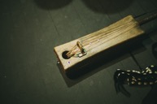
Palestinian composer, vocalist and musician, Kamilya Jubran has been leading music workshops with groups of young artists in Cairo, Ramallah and Haifa since 2014. Through these workshops, she realised the importance of providing a space where artists are invited to express themselves freely, to speak about the challenges they face and the hopes they have as musicians, but above all, a space where they can be listened to and accompanied through their projects.
Beirut & Beyond 2016 and Kamilya Jubran are joining forces to create this space in Beirut. On Friday 9 December, young artists based in Lebanon are invited to spend a working day with Kamilya, present their projects and benefit from her long professional experience. This first encounter will pave the way for a series of workshops with Kamilya that will be announced later in 2017 to further explore necessary tools for the development of their music project.

ELECTRONIC MUSIC WORKSHOP with Mats Lindstorm & Daniel Araya
In partnership with Irtijal, Elektron Musik Studion & Simsara
With the support of Beirut & Beyond International Music Festival, Irtijal - International Festival of Experimental Music in Lebanon, is holding a series of electronic music workshops for musicians based in the Arab region, in collaboration with the renowned Elektron Musik Studion (EMS) in Sweden, and communication /networking platform Simsara. The project aims at developing skills in electronic technology and equipment by sharing the advanced knowledge of EMS, through its two main protagonists, musicians and producers Mats Lindstrom and Daniel Araya, with the Lebanon-based musicians.
The first part of the workshop will take place from 5 to 9 December within the frame of Beirut & Beyond, followed by resulting concerts within the frame of Irtijal'17 in April 2017.

More information
Press release in doc format and high-resolution photos available here: http://www.beirutandbeyond.net/press/

Contact
Karim Massoud
press@beirutandbeyond.net
+961 76760212

